**Assignment – 4**

**“Grafana”**

1. update :- sudo apt update -y
2. **For Managing software from the terminal :-sudo apt-get install -y**

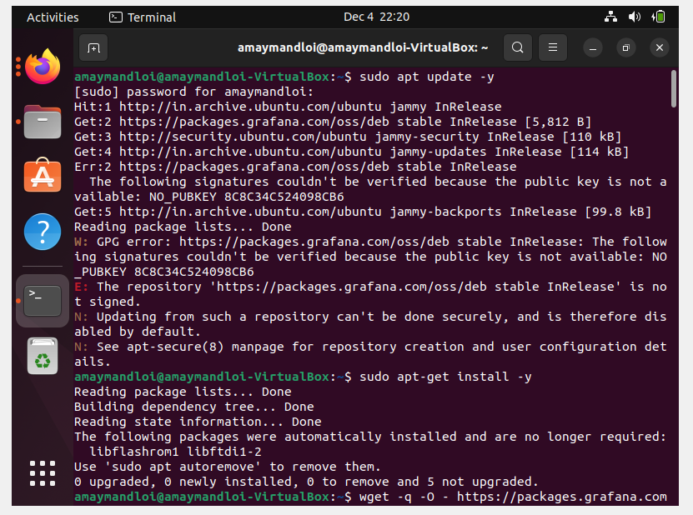

1. Add package.grafana for key add :- wget -q -O - https://packages.grafana.com/gpg.key | sudo apt-key add –

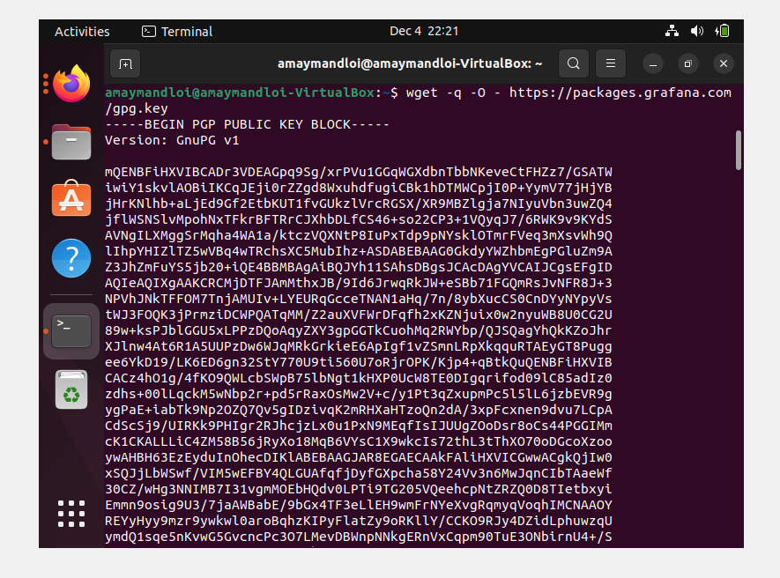

1. Add the beta Repository :-

sudo add-apt-repository "deb https://packages.grafana.com/oss/deb stable main"

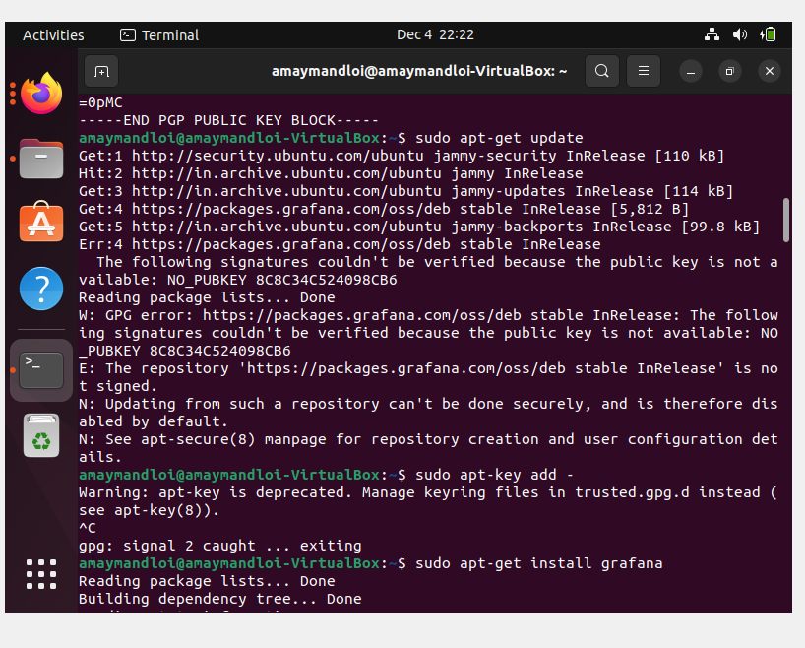

1. Sudo apt-get update and install Grafana :- sudo apt-get install Grafana

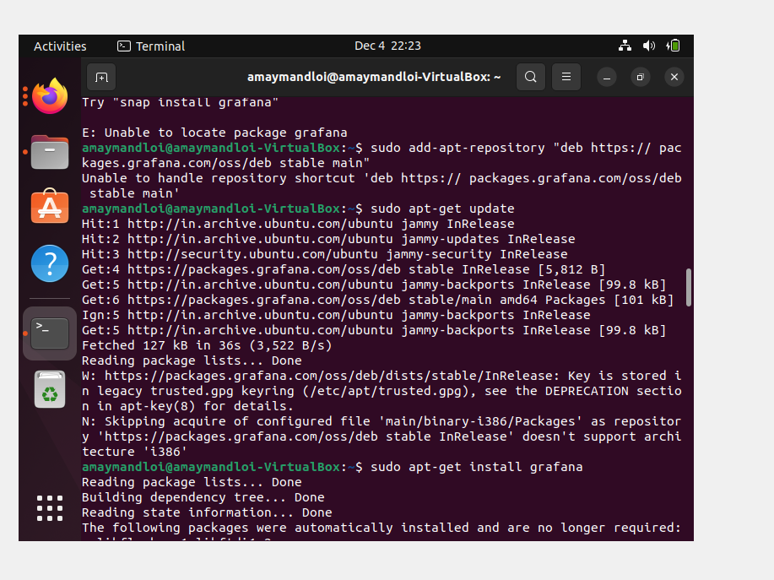

1. Add Repository for Stable Main

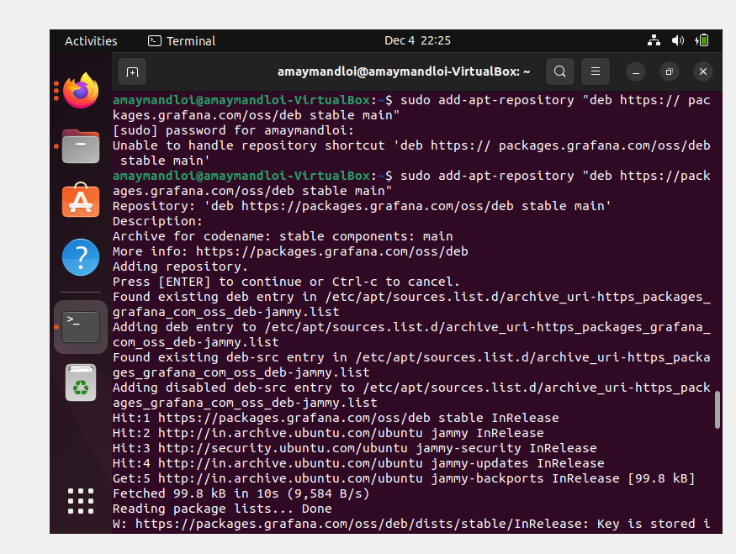

7. 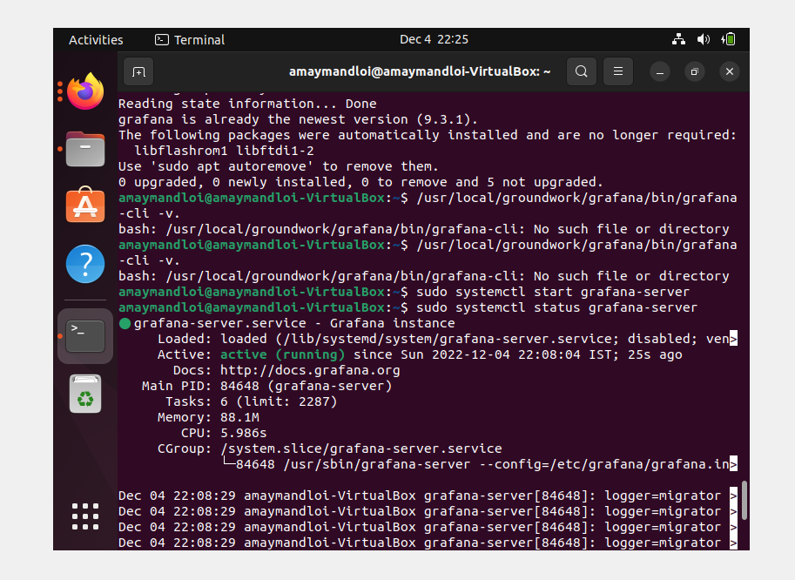

8.



9.

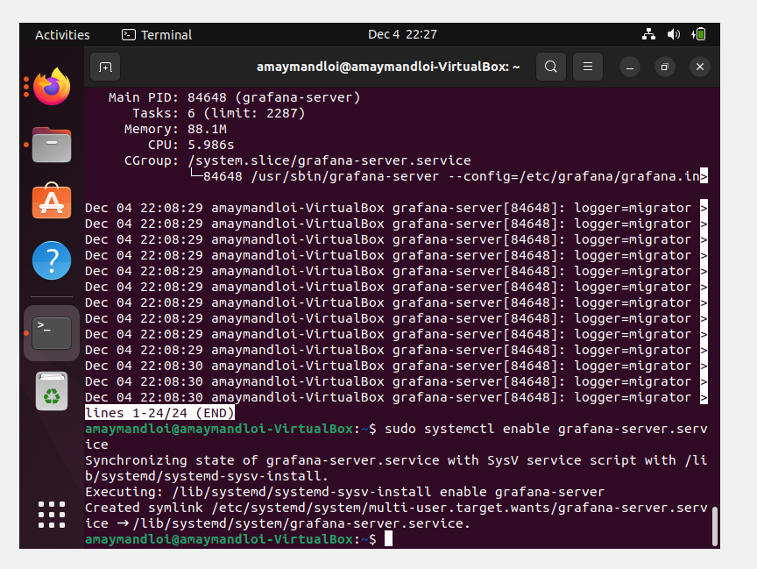

10.

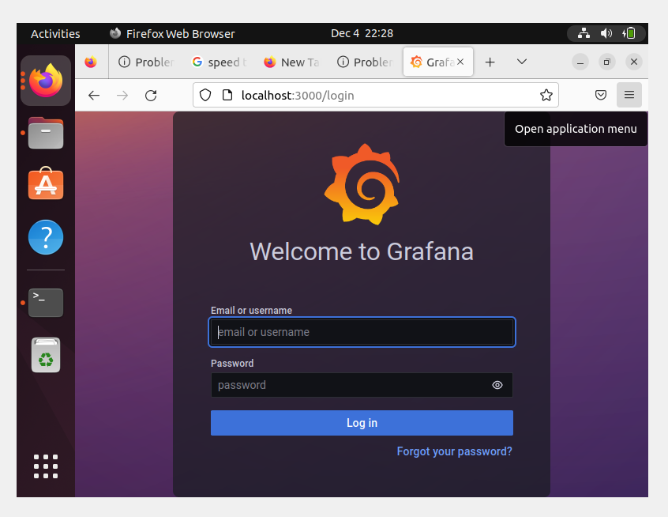

11.

